AST Manual - Harry Jerome Arena

- Set Up:

- AST must arrive 20 minutes minimum before the ice time.
- Use “Community Sports Entrance” to HJ - West doors beside play park at the corner of Lonsdale and 23rd. See HJ Directional flow map attached.
- NVMHA supplies are stored under the stairs as you enter.
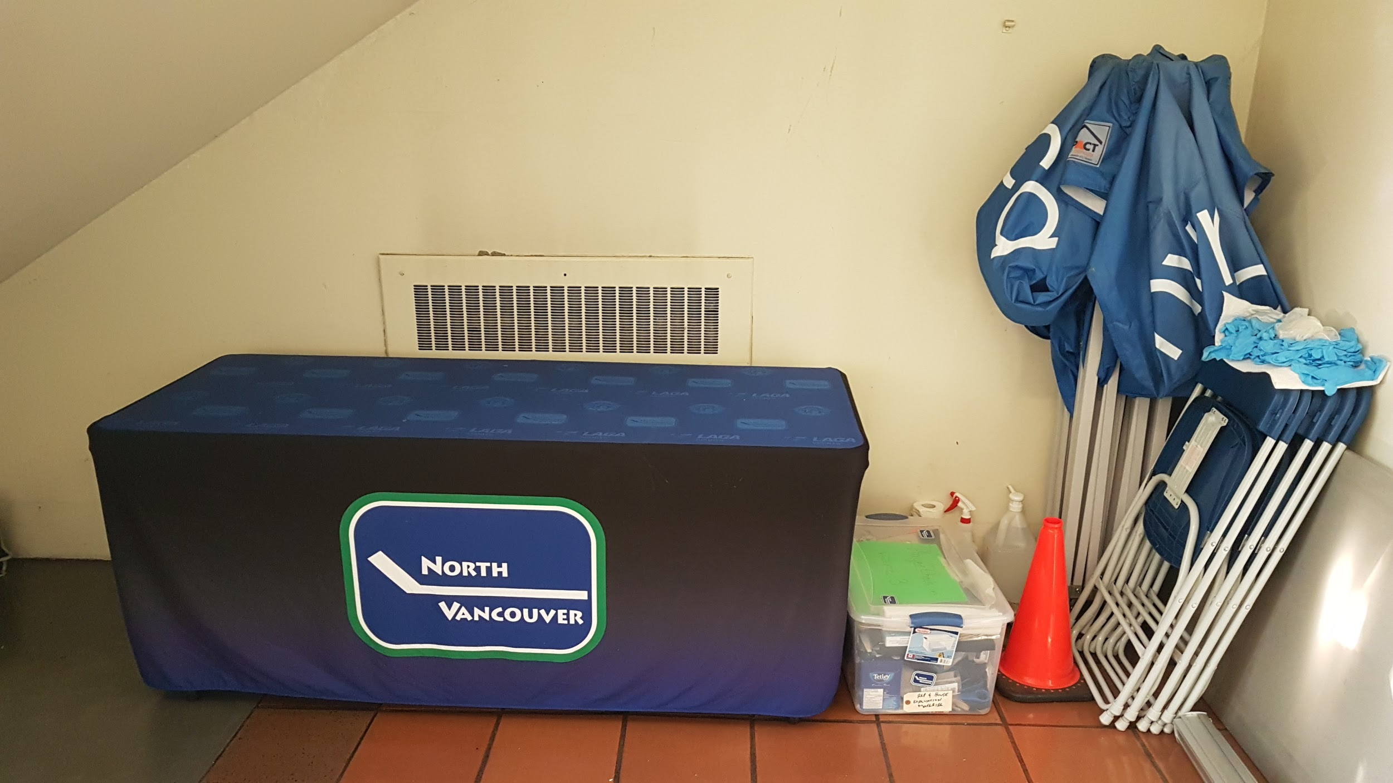
- Clean your hands, put on your mask and a safety vest.
- Only players, coaches, HCSP and AST allowed inside HJA and HCSP and AST must be wearing a safety vest to ensure HJA staff can identify you.
- Set Up in the area across from the play park to check in players.
- Set up cones to mark the 4 lines of players
- Players stand on spots marked by yellow tape
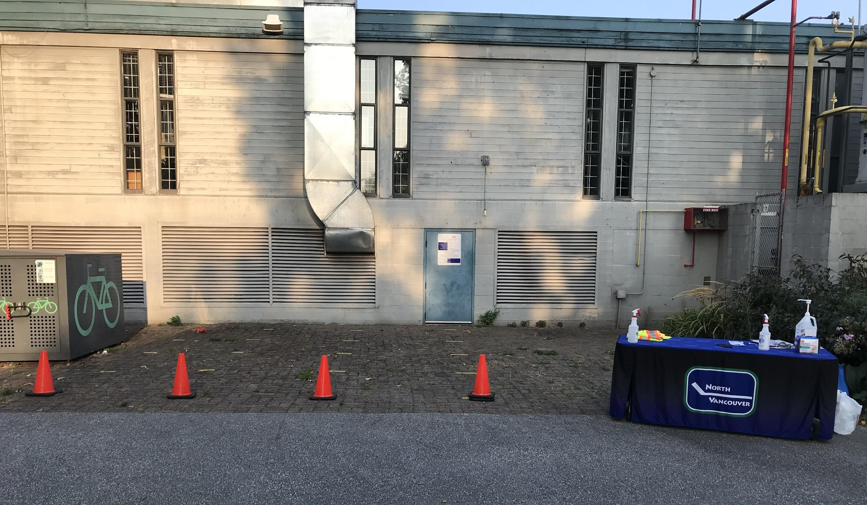

- Check in Players
- AST must ensure each player is WEARING A FACE MASK and has completed their Teamsnap Health Check - either by confirming with team manager OR having each player/guardian show you the completed Health Check on the Teamsnap App.
- AST to spray players hands with sanitizer before entering the building
- Use White spray bottle marked “TRITON” Hand sanitizer to spray hands.
- Do not use green “SPIRIT II” or white “SABRE” spray cleaners to sanitize hands.
- There are spray bottles AND refills located with the supplies under the stairs. Please use gloves provided to refill SPIRIT II AND SABRE bottles.

- Lead Players to the Arena Lobby
- 10 min prior to Ice time AST leads players into building through west doors, minding directional arrows and signs in the building, to the lobby of HJ Arena
- Players may sit on spots marked by an X on South side lobby benches in designated area controlled by AST volunteers
- The North and South ends of the lobby will be sectioned off with pylons.

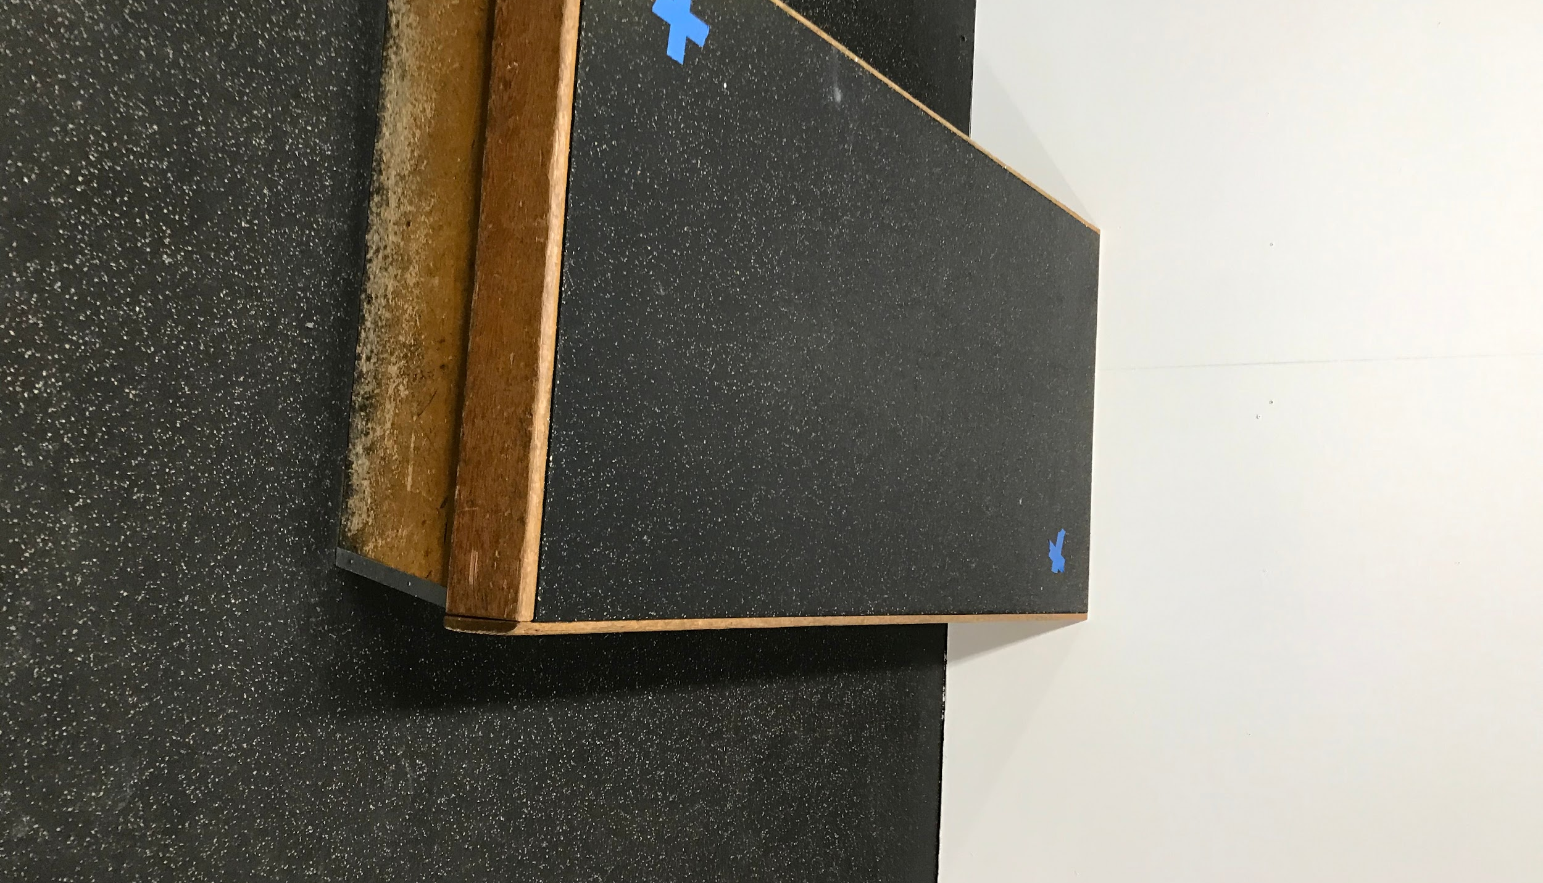
- AST remains in lobby with players to ensure social distancing is maintained.
- Once ice is clear -players take their bags, and coaches and AST will lead the players through the North doors leading to the ice as per directional HJ map
- 10 players will place their bags in the designated spot in North end of lobby and remaining players will place their bags on the first and second row of bleachers and take the ice.

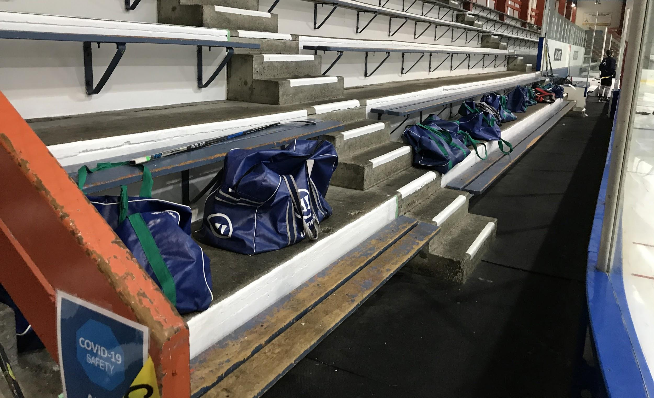

- Disinfect Player Benches and All Touch Surfaces
- AST then uses “SABRE” (no wiping needed) spray disinfectant or “SPIRIT II” spray and wipe disinfectant cleaner to wipe down all benches and touch surfaces used by the players in the entrance and the arena lobby areas.

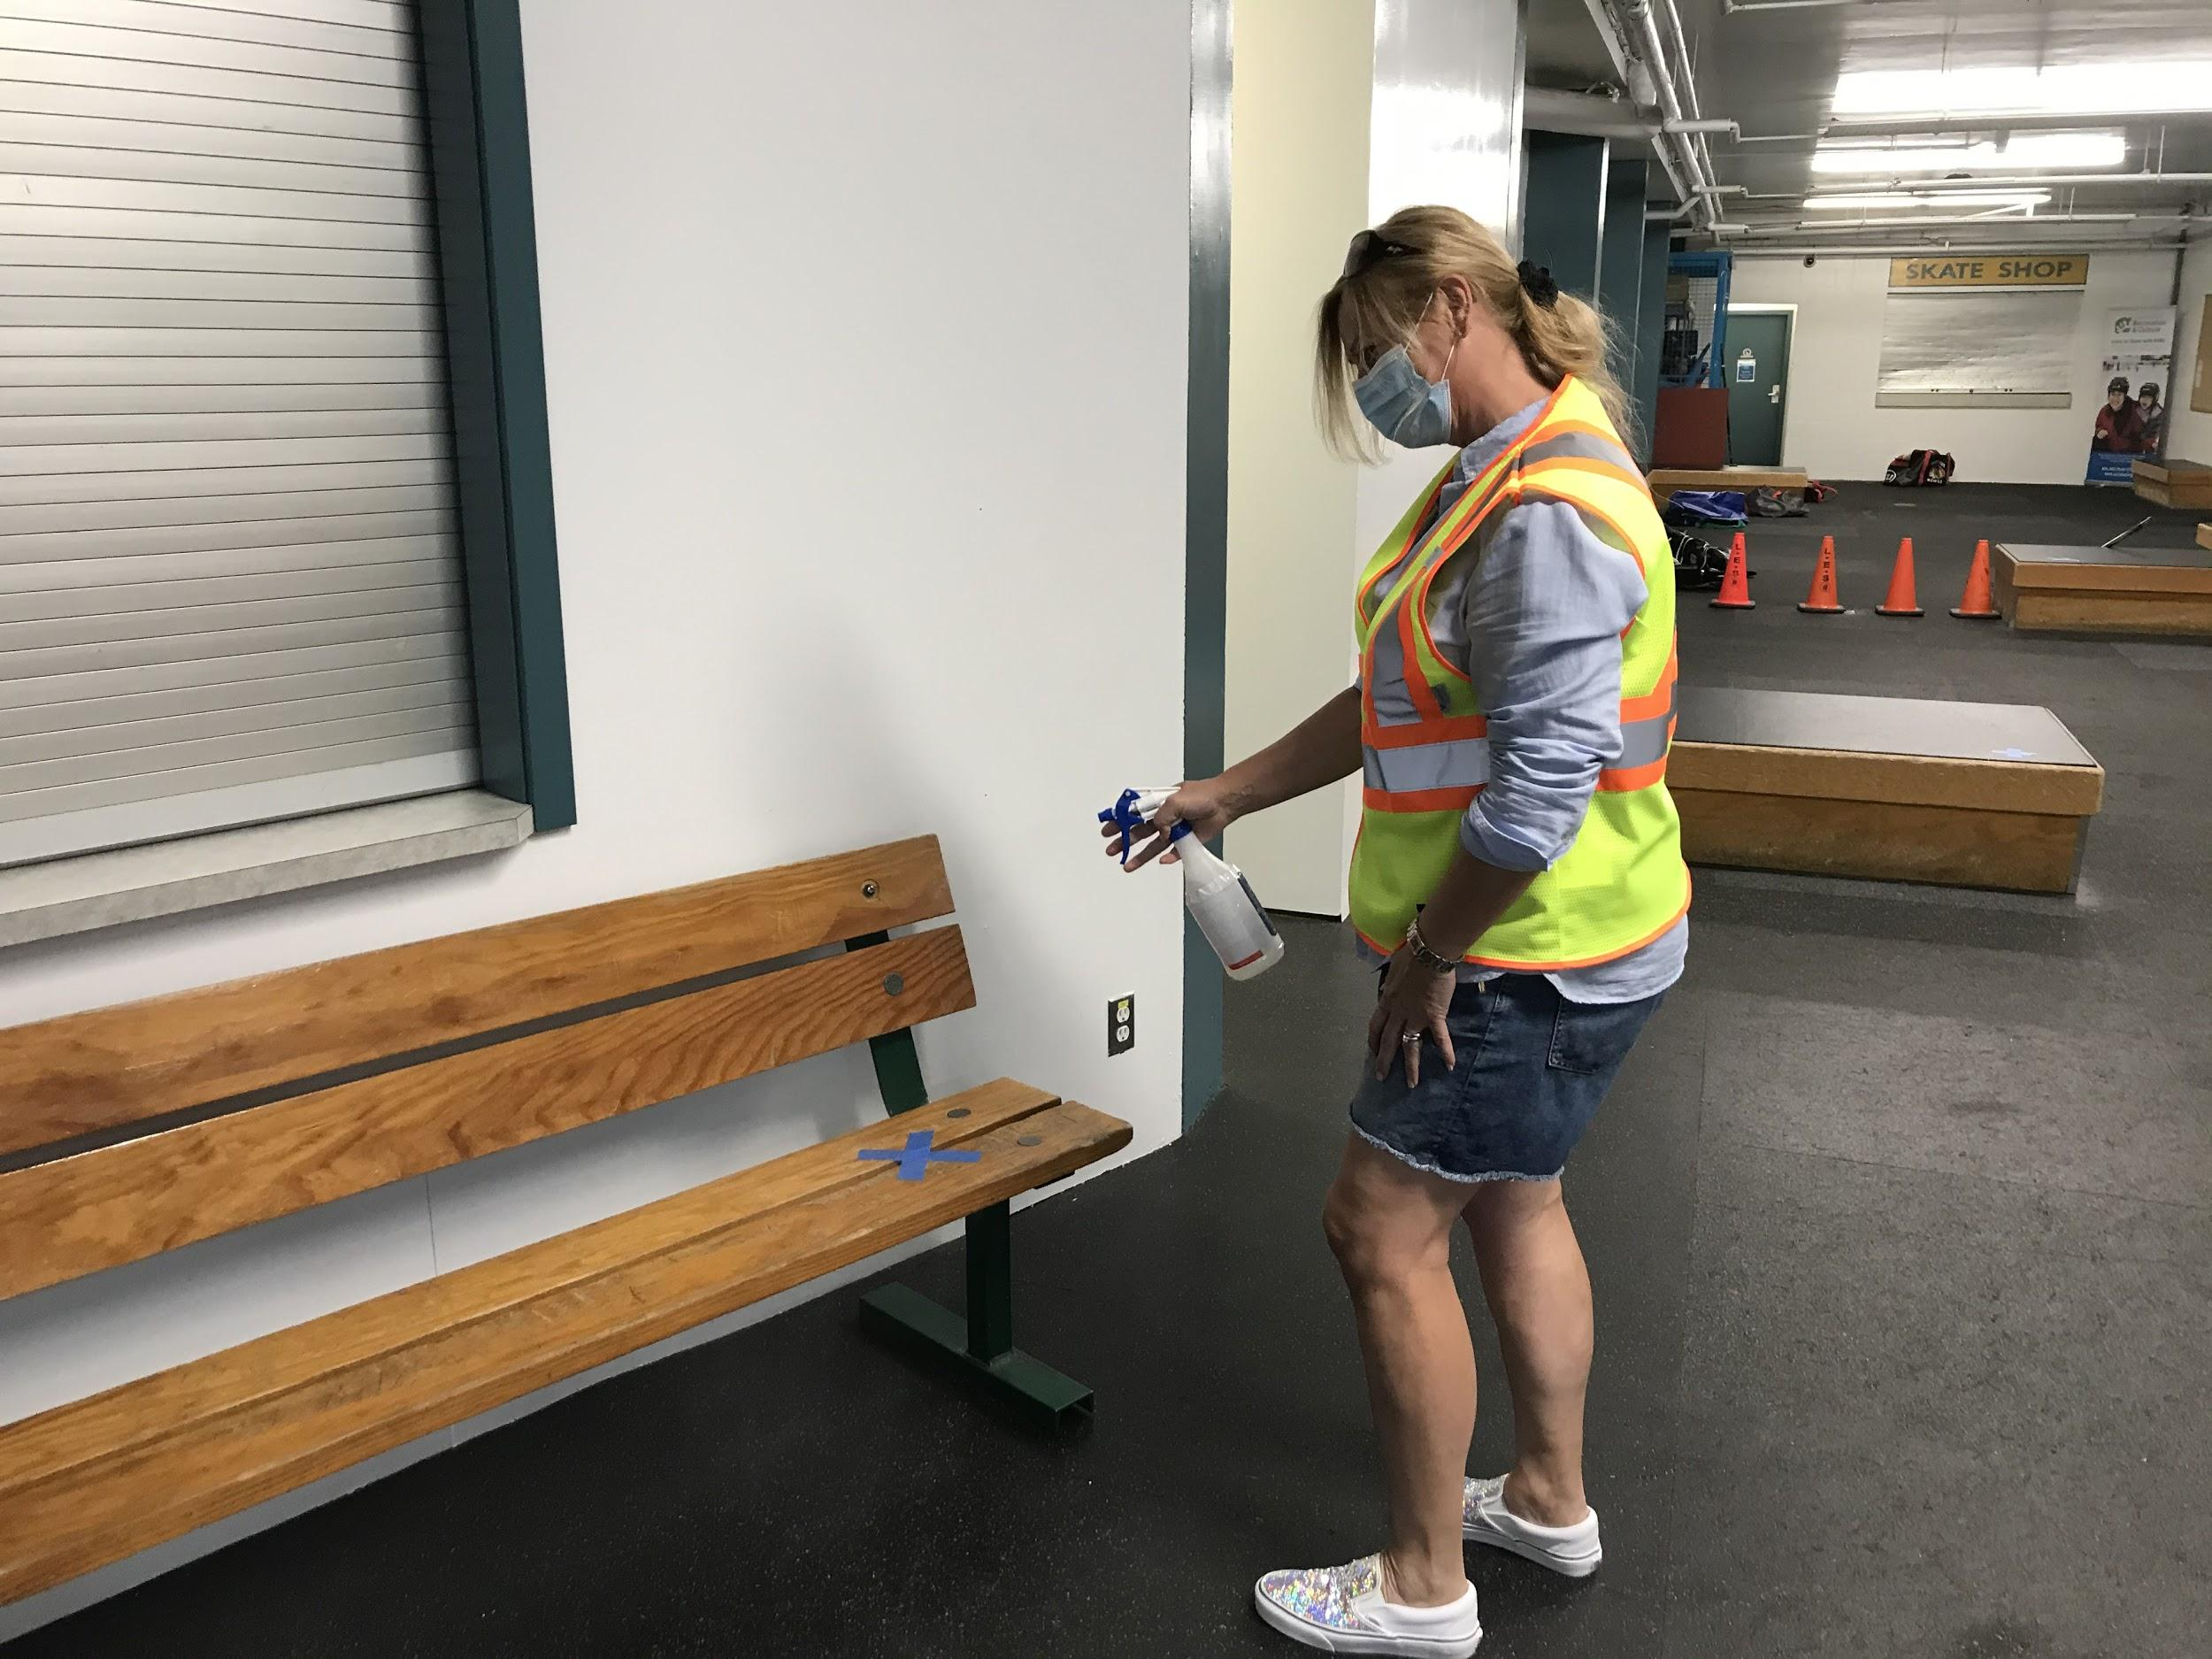

- During Hockey Session:
- One AST member then stands at the entrance door to admit any late players and prevent any non-authorized people from entering.
- One AST member remains in the arena to assist coaches if there is any need

- Lead Players to Exit

U13-18 Players
- Following the ice session the players sit at their bags on the first or second row of bleachers or enter back into North end of Lobby to remove skates or put on skate guards, then AST leads players to exit at North doors directly off arena (up the stairs on to 23rd street)

U11- and Under

- As above but AST leads them back through the lobby to exit through the same doors that they came through. *See Arena directional flow map attached.
- AST sprays sanitizer on players' hands as they exit the building.

- Final Disinfectant and Clean Up

- Disinfect benches and touch surfaces that were used by players inside arena
- Return vests, cones, sanitizer and cleaners to the storage area under the stairs. Spray Safety vests with hand sanitizer and set out to air dry.
- Done!

References: 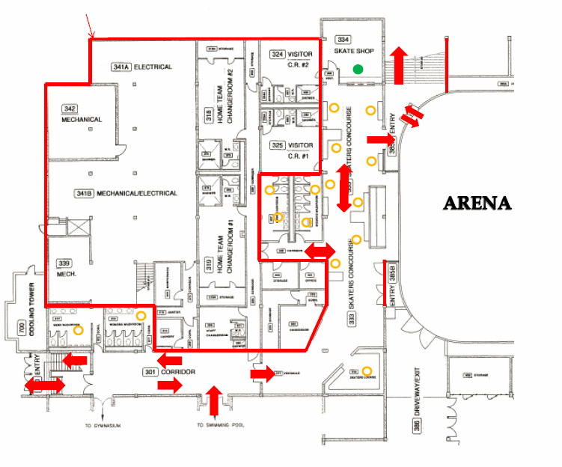

SABER Disinfectant spray: just spray and leave. No wiping needed. If there is no SABER then use SPIRIT II and wipe with paper towel/rags provided.
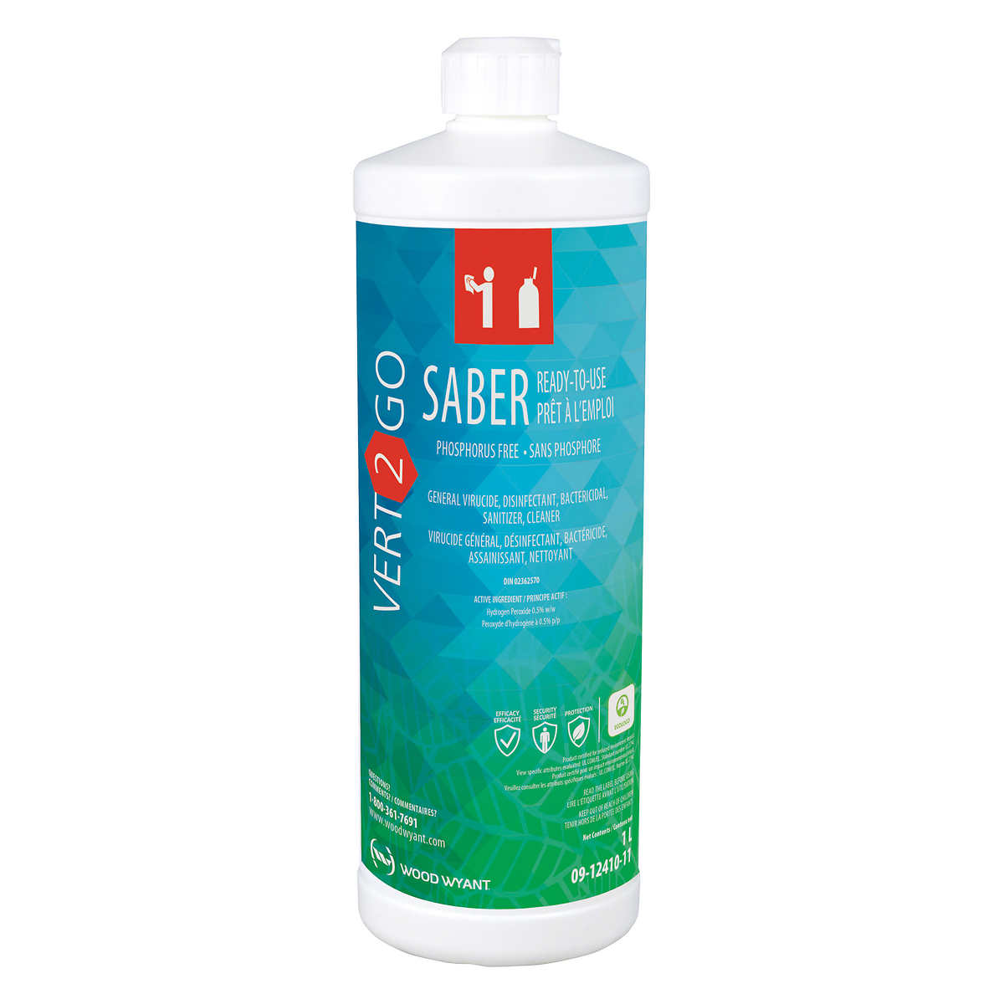
Triton Hand Sanitizer: in the white spray bottles
